**Qatar University**

**College of Engineering**

**CMPS 405: Operating Systems**

**Fall 2024**

**(Section B04)**

**Project Phase-1**

***Submitted to:***

Dr. Heba Dawoud

|  |  |  |
| --- | --- | --- |
| **Student** | **Name** | **ID** |
| **#1** | Nafin Mahmoud | 201913152 |
| **#2** | Khamis Al-Kubaisi | 201707893 |
| **#3** | Khalid Abdallah | 202106376 |
| **#4** | M.Reyad Tuama Halabi | 201902988 |

**Server-Side Tasks (VM1)**

Task-1:

- Create local user accounts for each client on the server.









- Install and enable SSHD

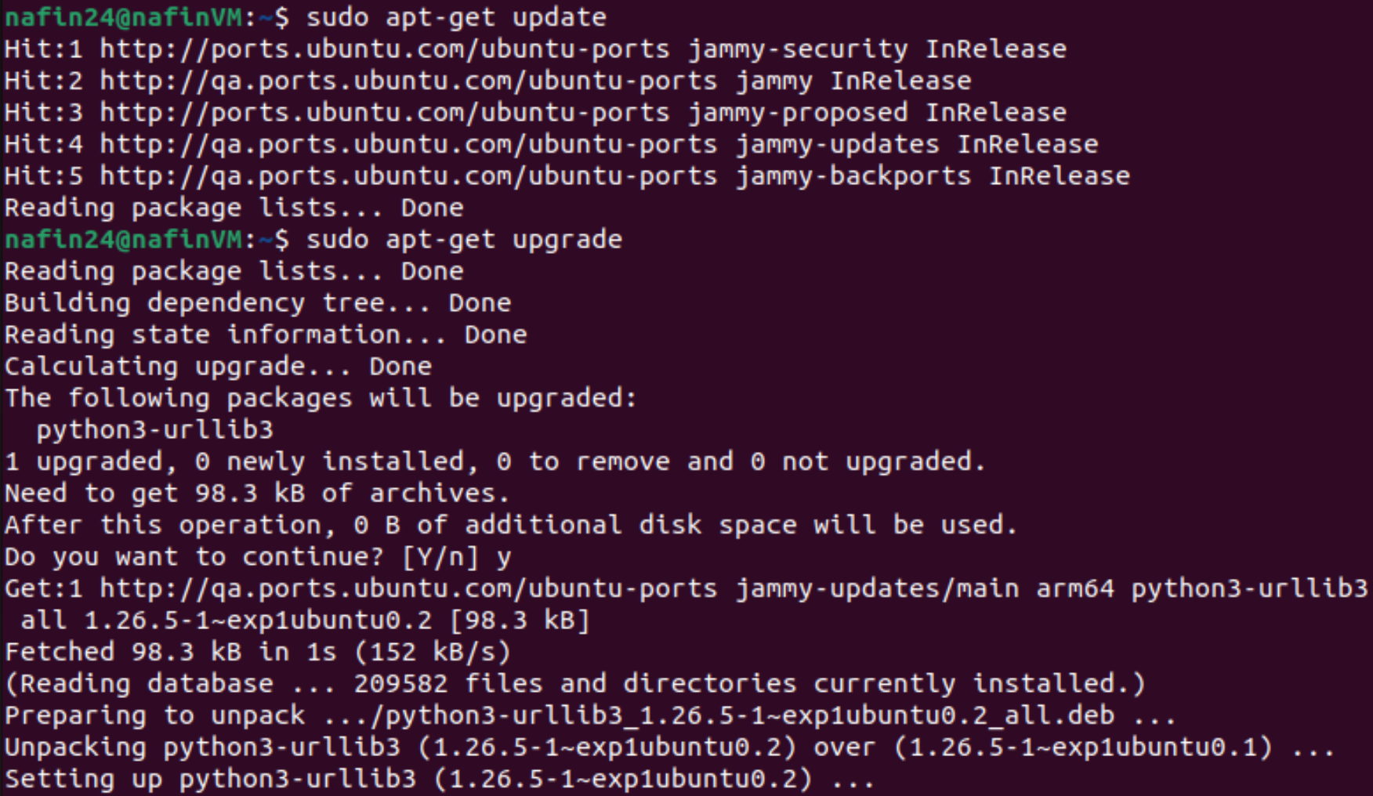

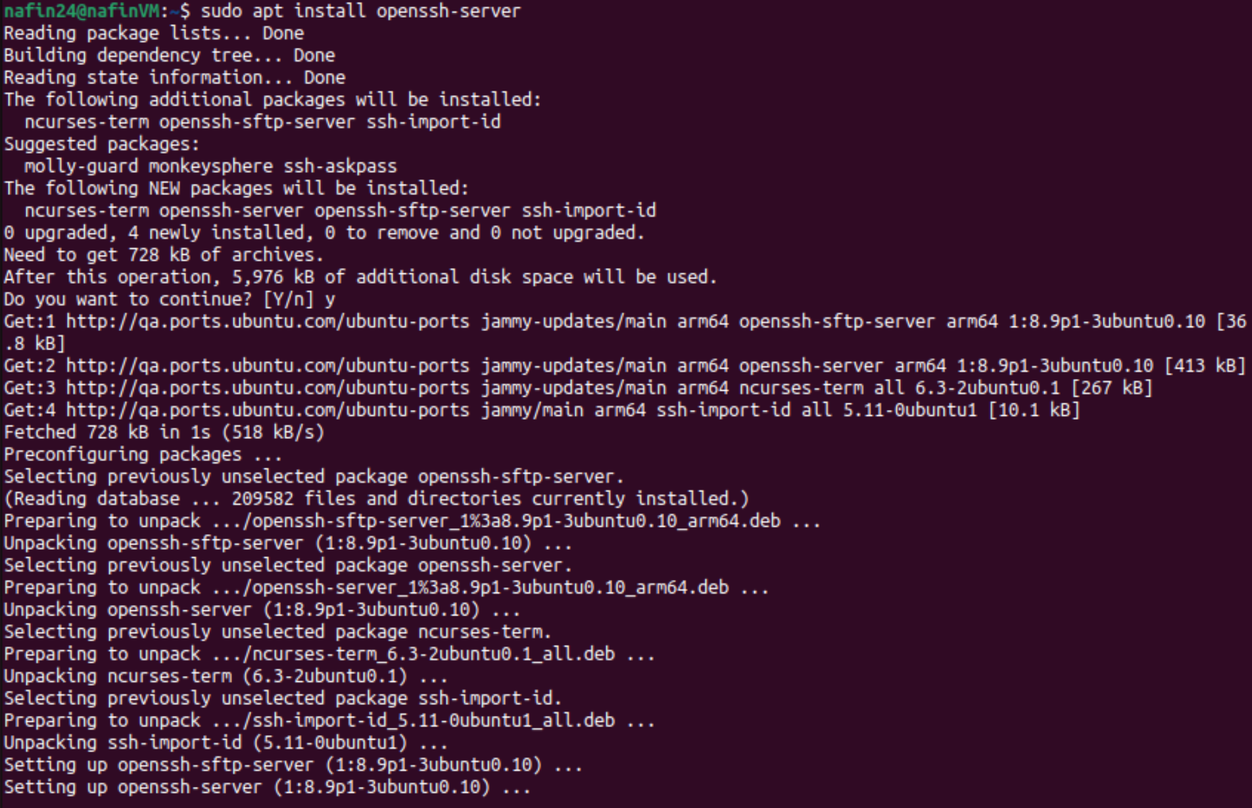



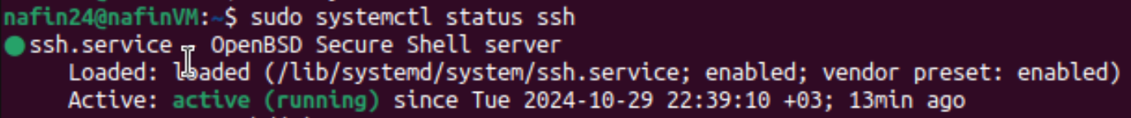

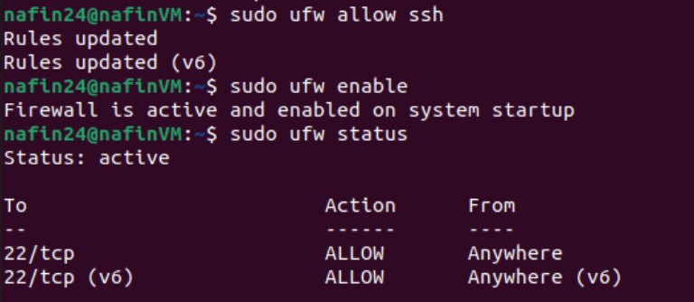

- Configure SFTP for file transfer operations.



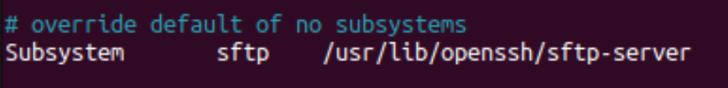

Task-2:

* Enable SSH access for clients using local account credentials, that is, configure SSHD server such that clients can access any file via their local accounts, using username and password.
* Set up SFTP for file uploads/downloads.
* Secure copy will be used to transfer files to and from server.



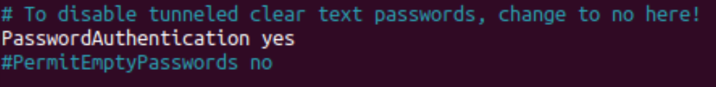



Task-3:

* ***Output samples of network.sh and traceroute.sh :***

Testing without providing ip:

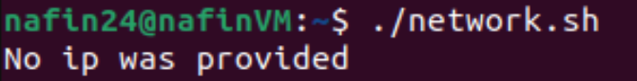

Testing client1 VM2 (192.168.66.129):

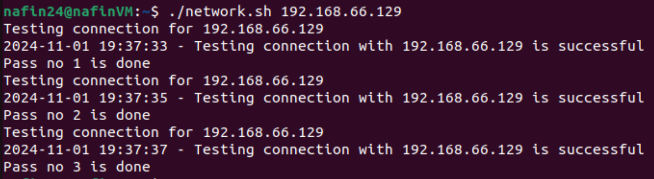

Testing client1 VM2 (192.168.66.129) and client2 VM3 with wrong ip to enforce traceroute:

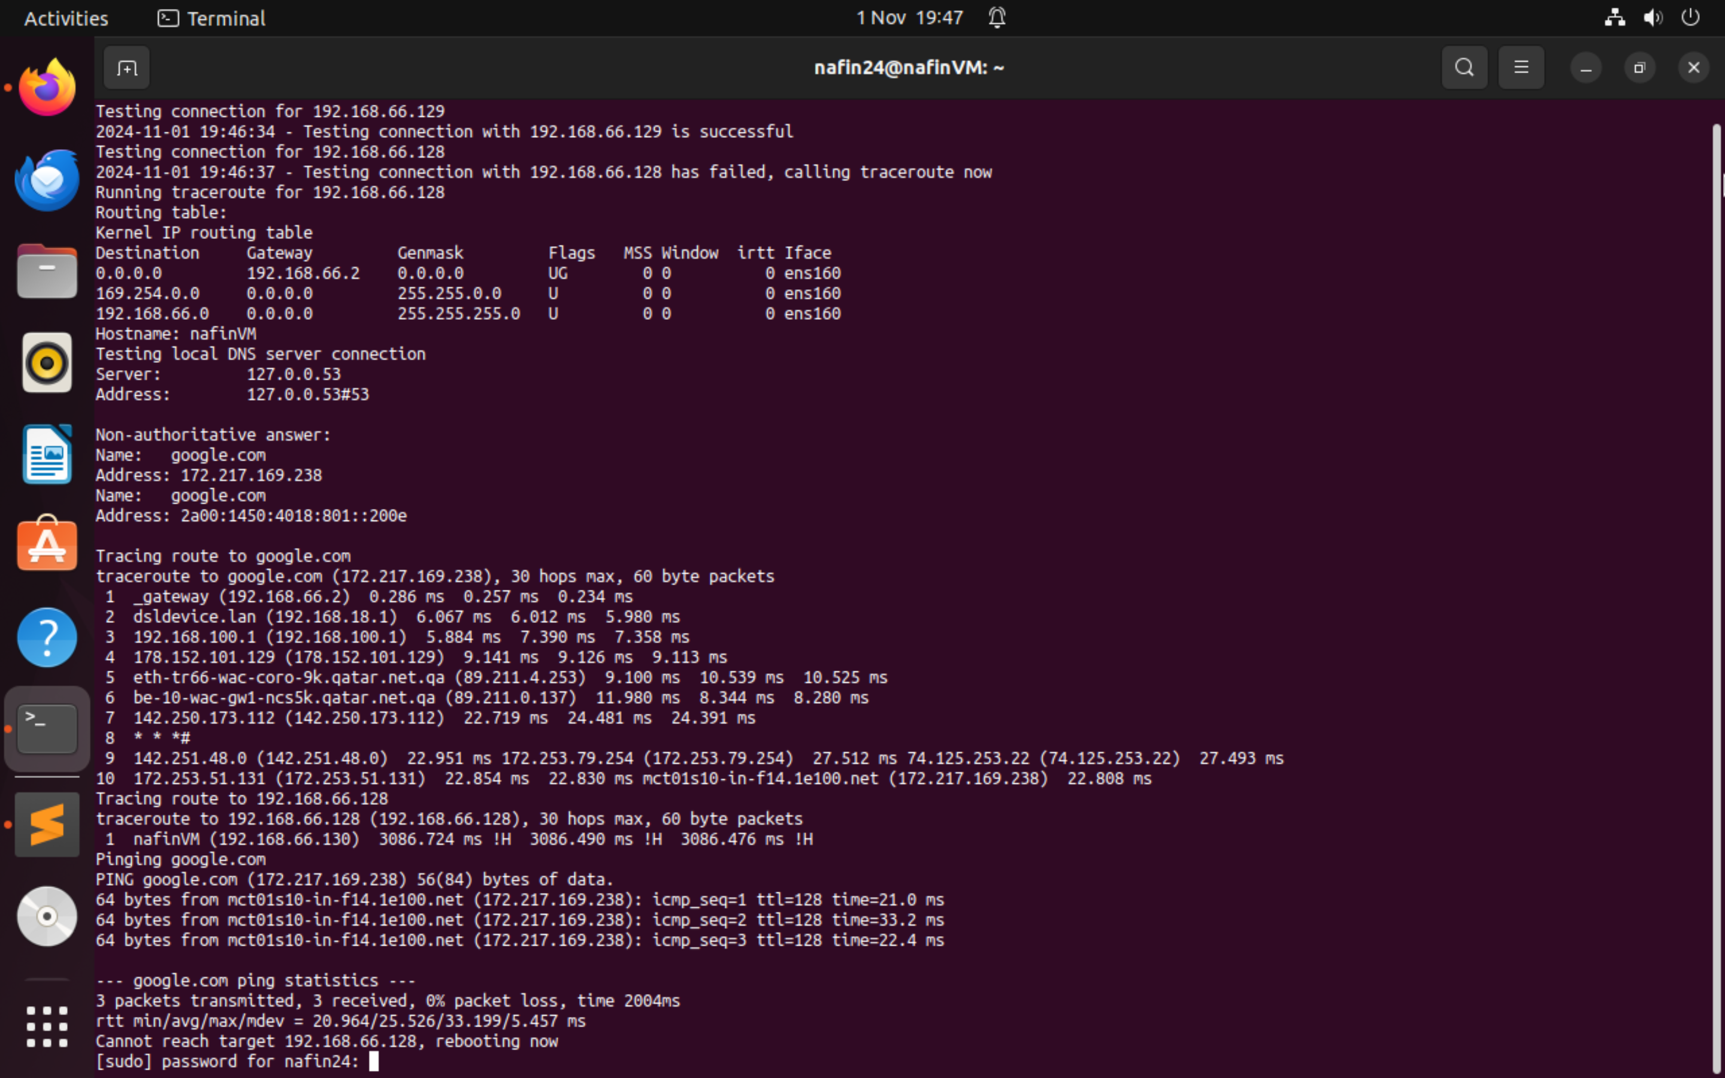

Log file is created for both scripts

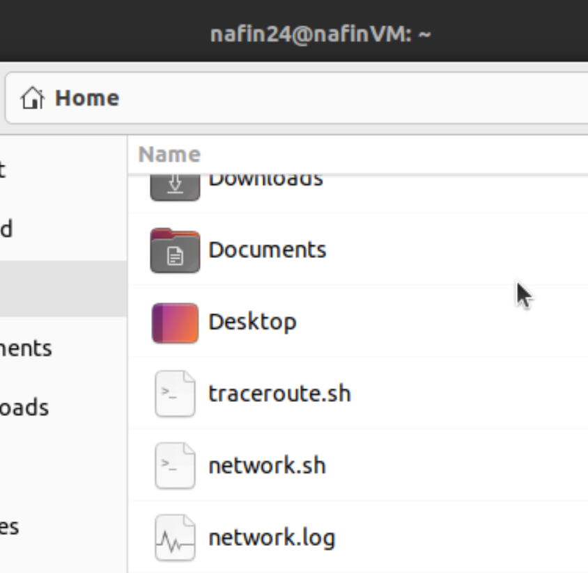

* ***Output sample of System.sh :***

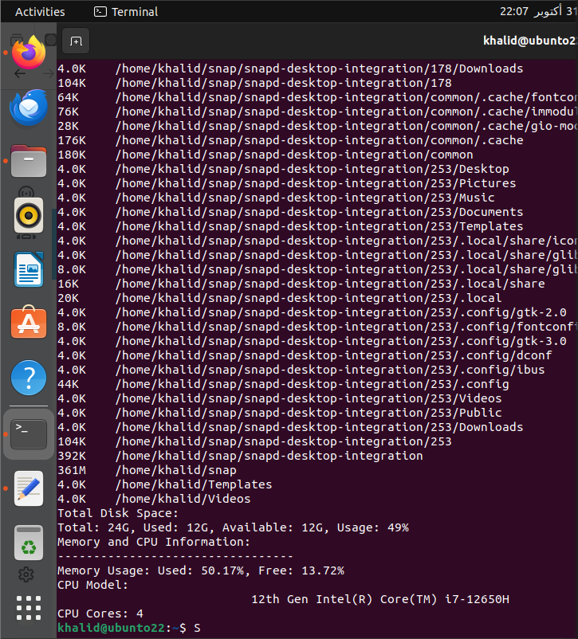

**Client-Side Tasks (VM2 and VM3)**

Task-1:

* Validate that SSH is installed and enabled (SSH is installed by default on most systems).
* Install an SFTP client.

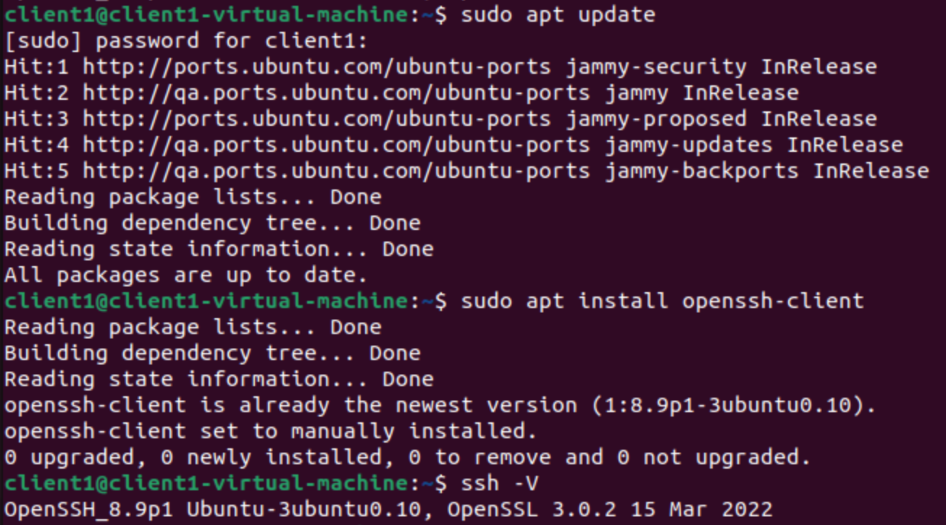

* Ensure SCP (Secure Copy) is available for file transfers.

In client1 VM2:

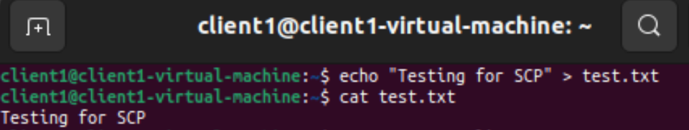

In client1’s directory from server VM1 :

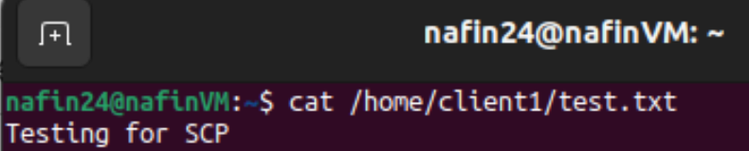

Task-2:

* SSH and SFTP Configuration:

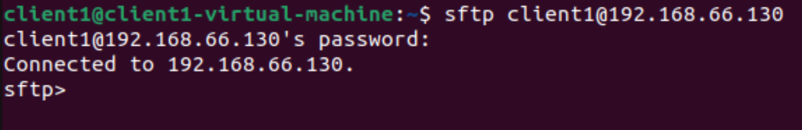

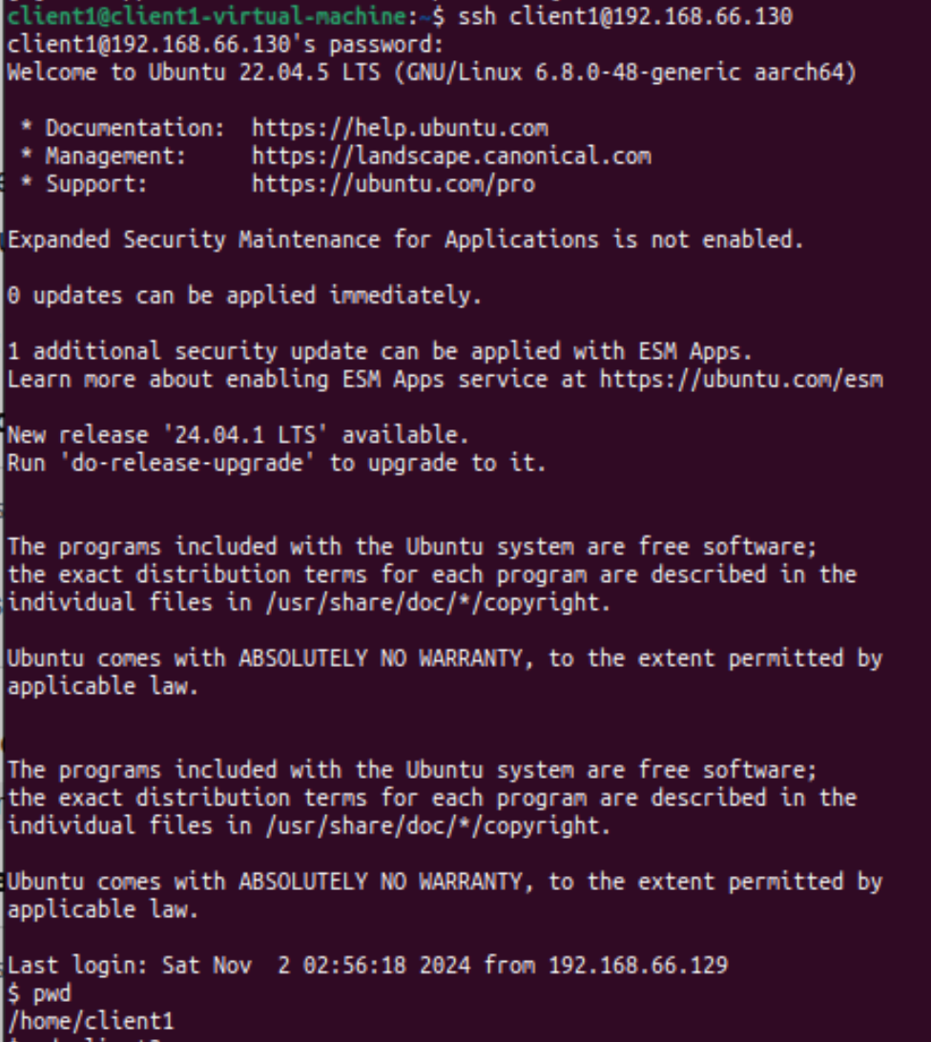

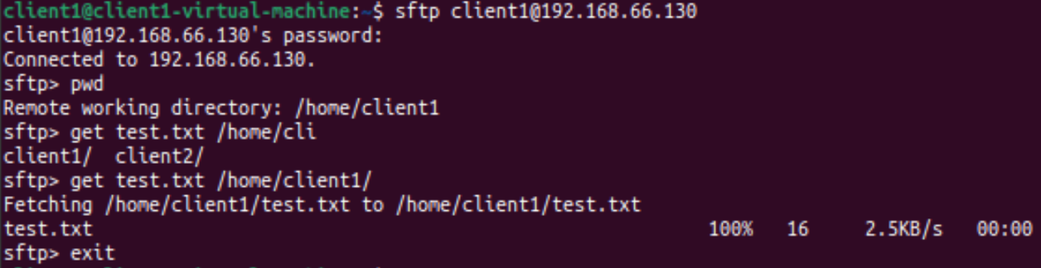

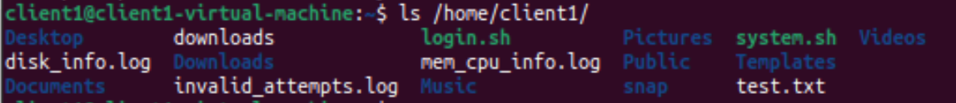

Task-3:

* ***Output samples of Search.sh and Clientinfo.sh :***

Listing the contents of home directory:



After runnning (Search.sh), we can see that the file (bigfile.log) is created, where the results are stored: 

Viewing the contents of (bigfile.log): 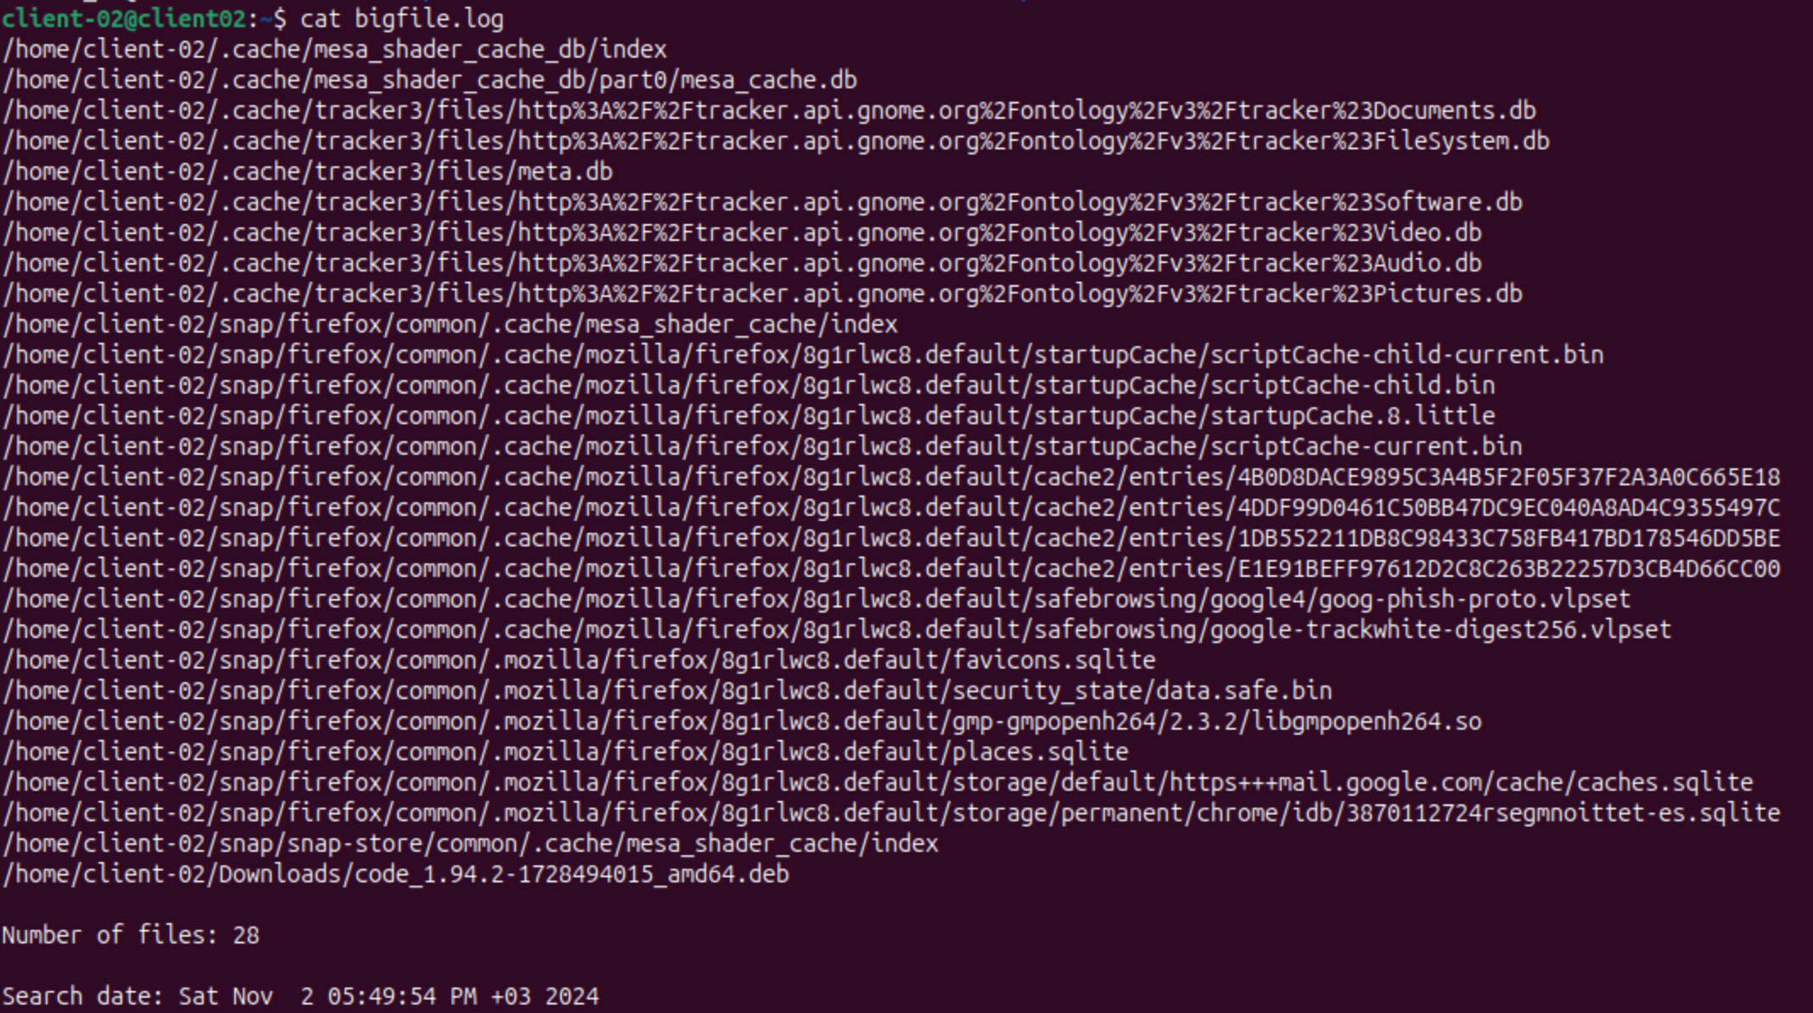An email with contents of (bigfile.log) is received: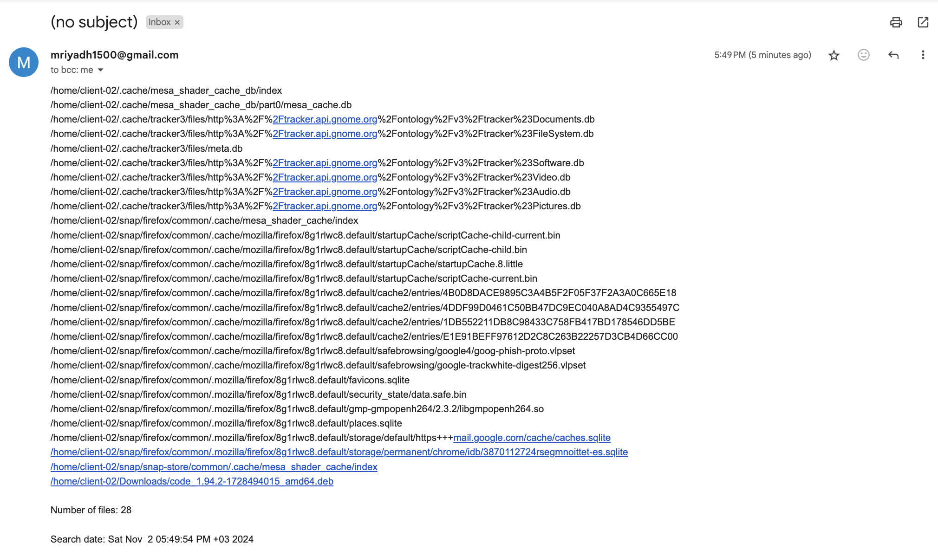

Listing the contenst of home directory before running (Clientinfo.sh): After running (Clientinfo.sh), we can see that the file (process_info.log) is created, where the results are stored:

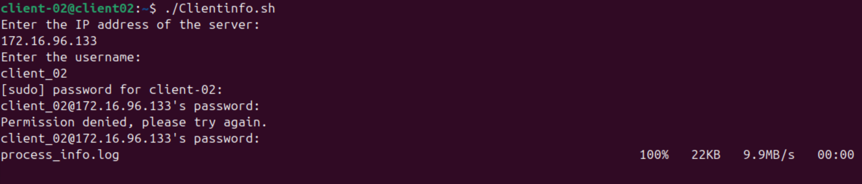Viewing the contents of (process_info.log):

Note: since the file is so big, only the important parts are shown here: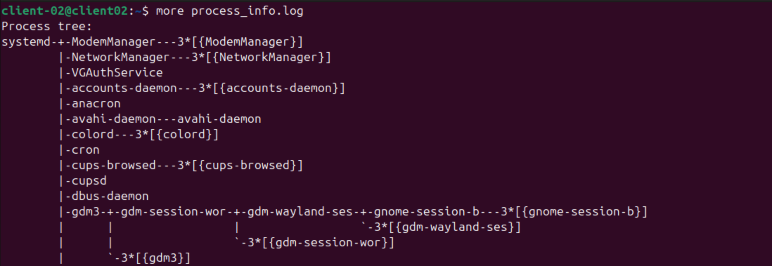…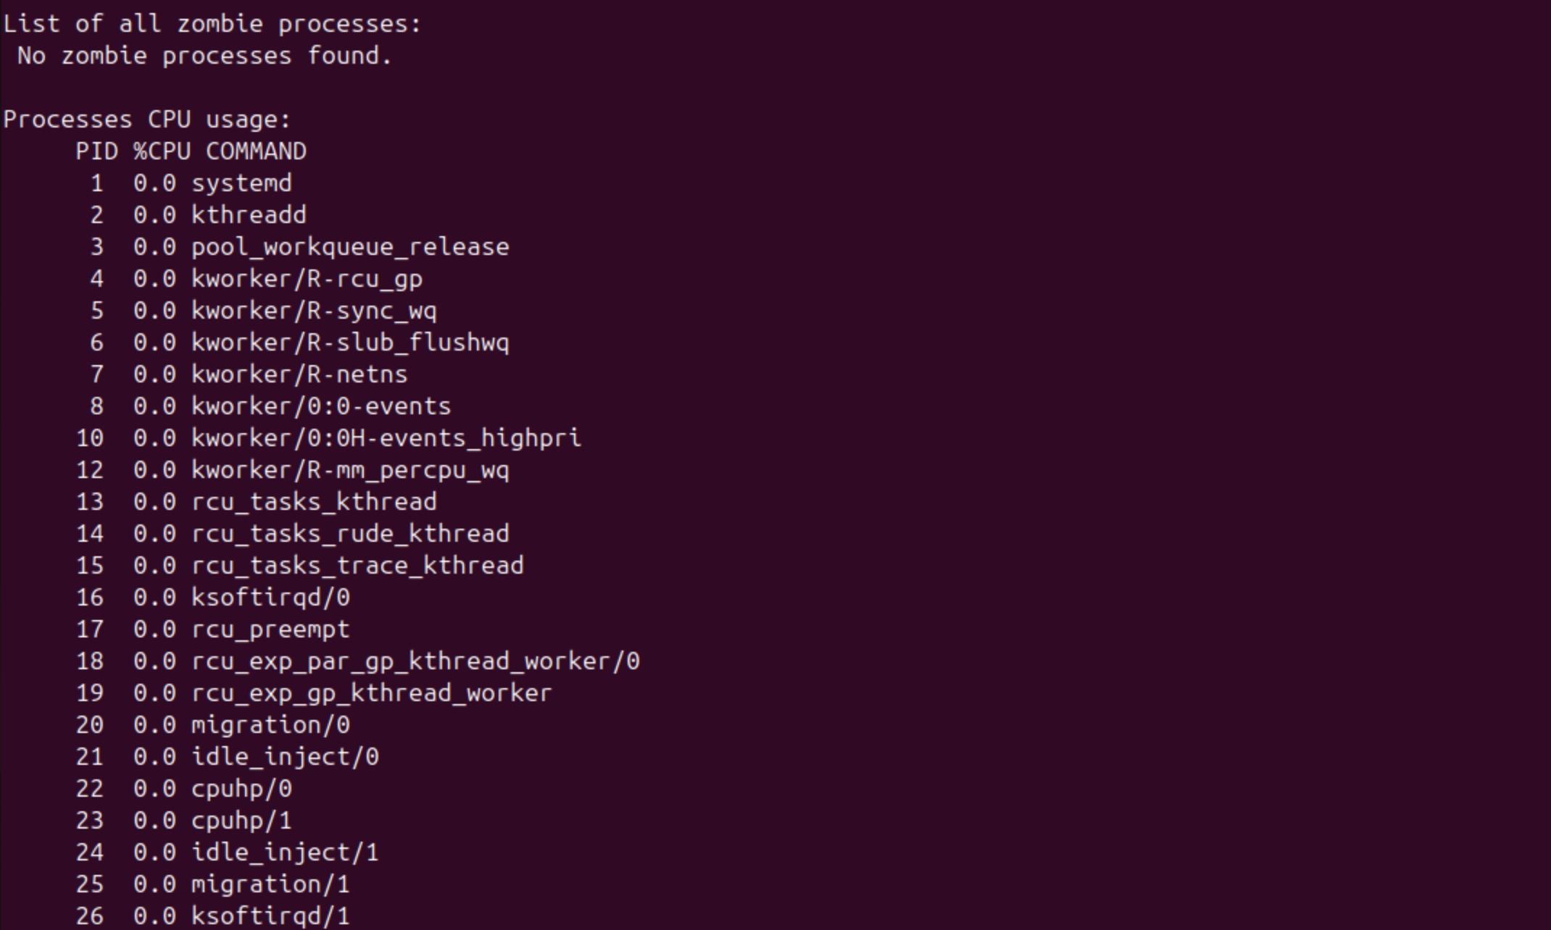… 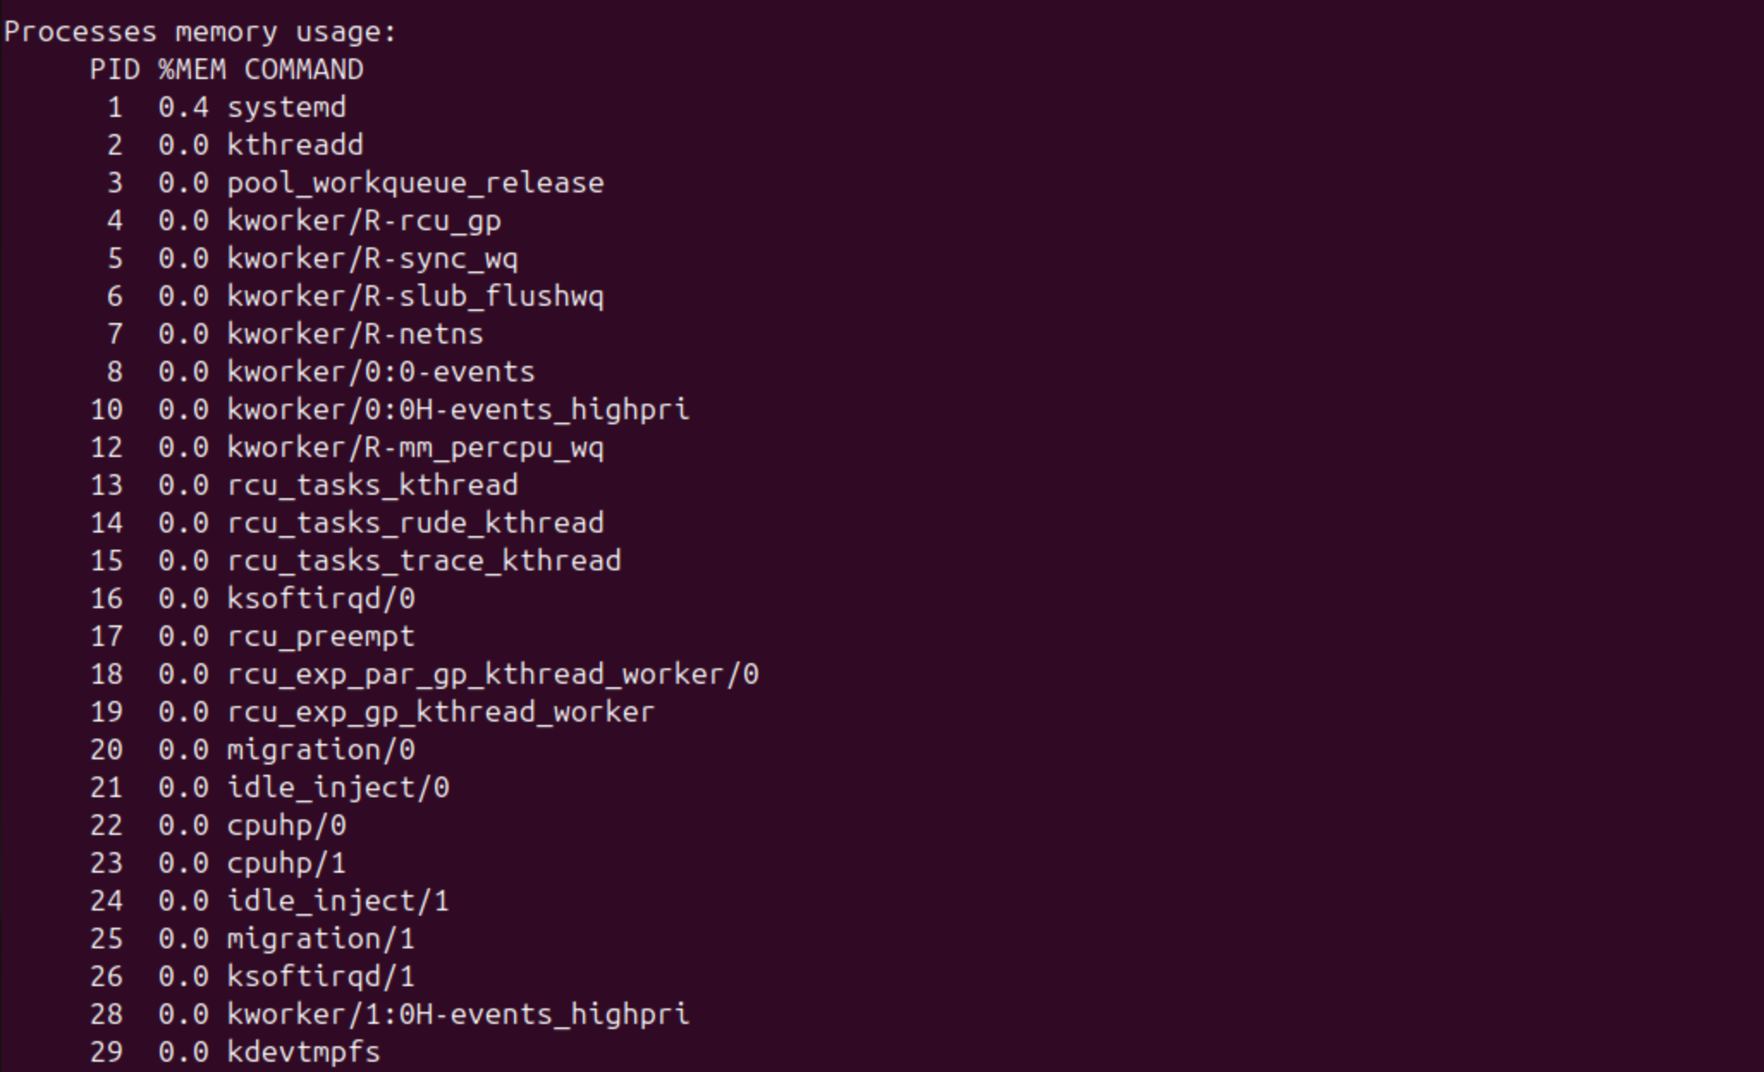… 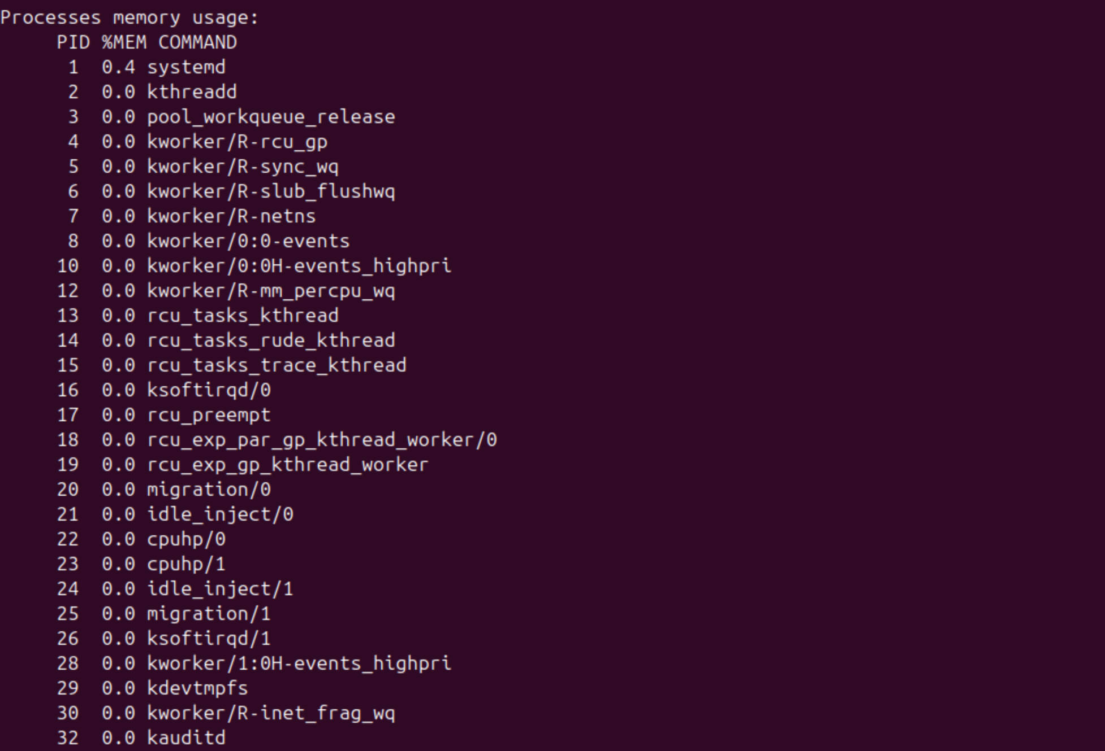… 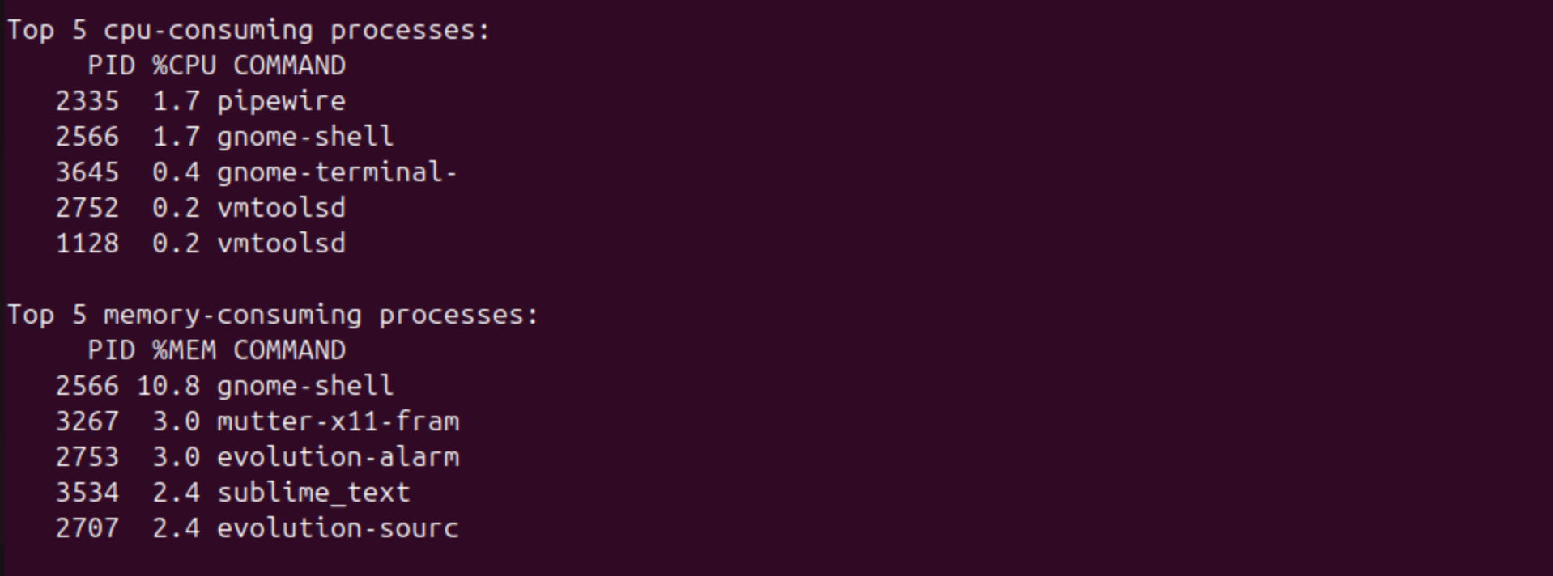Verifying that the file was sent to the server: 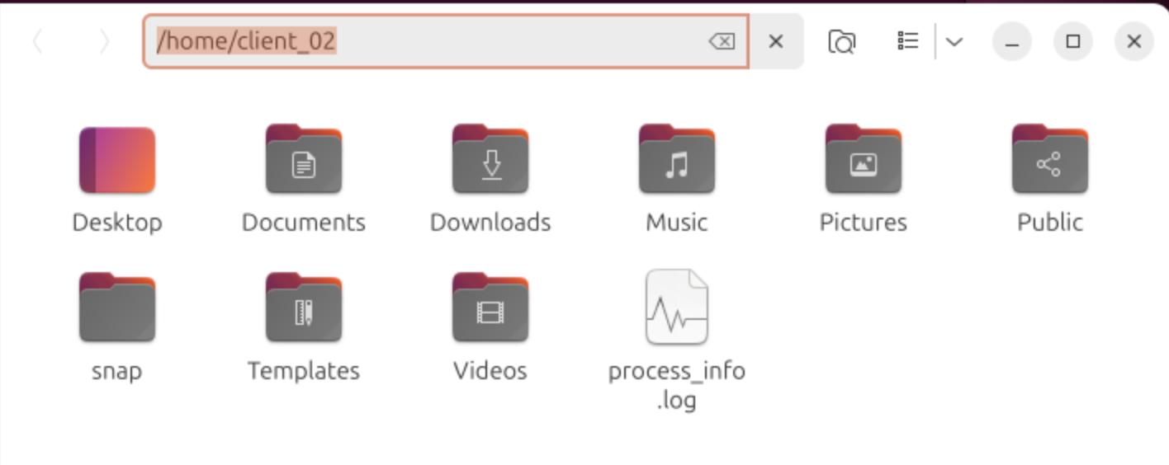Viewing the file in the server: 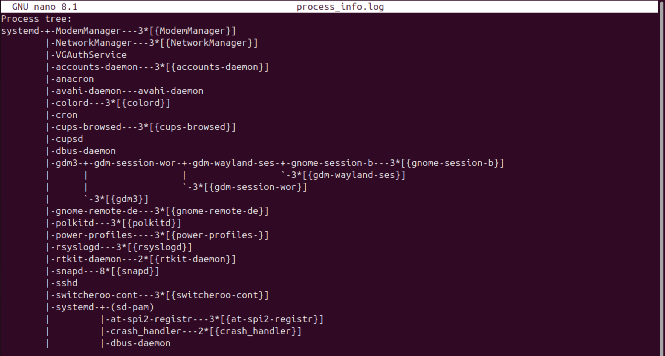… 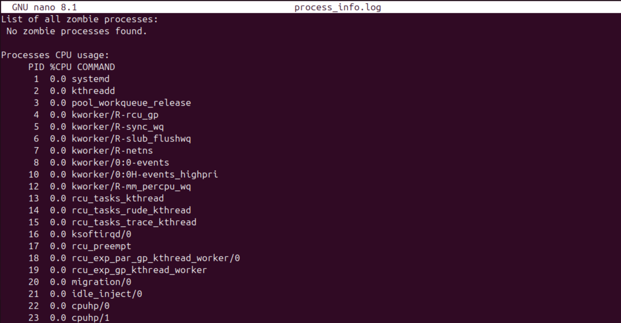… 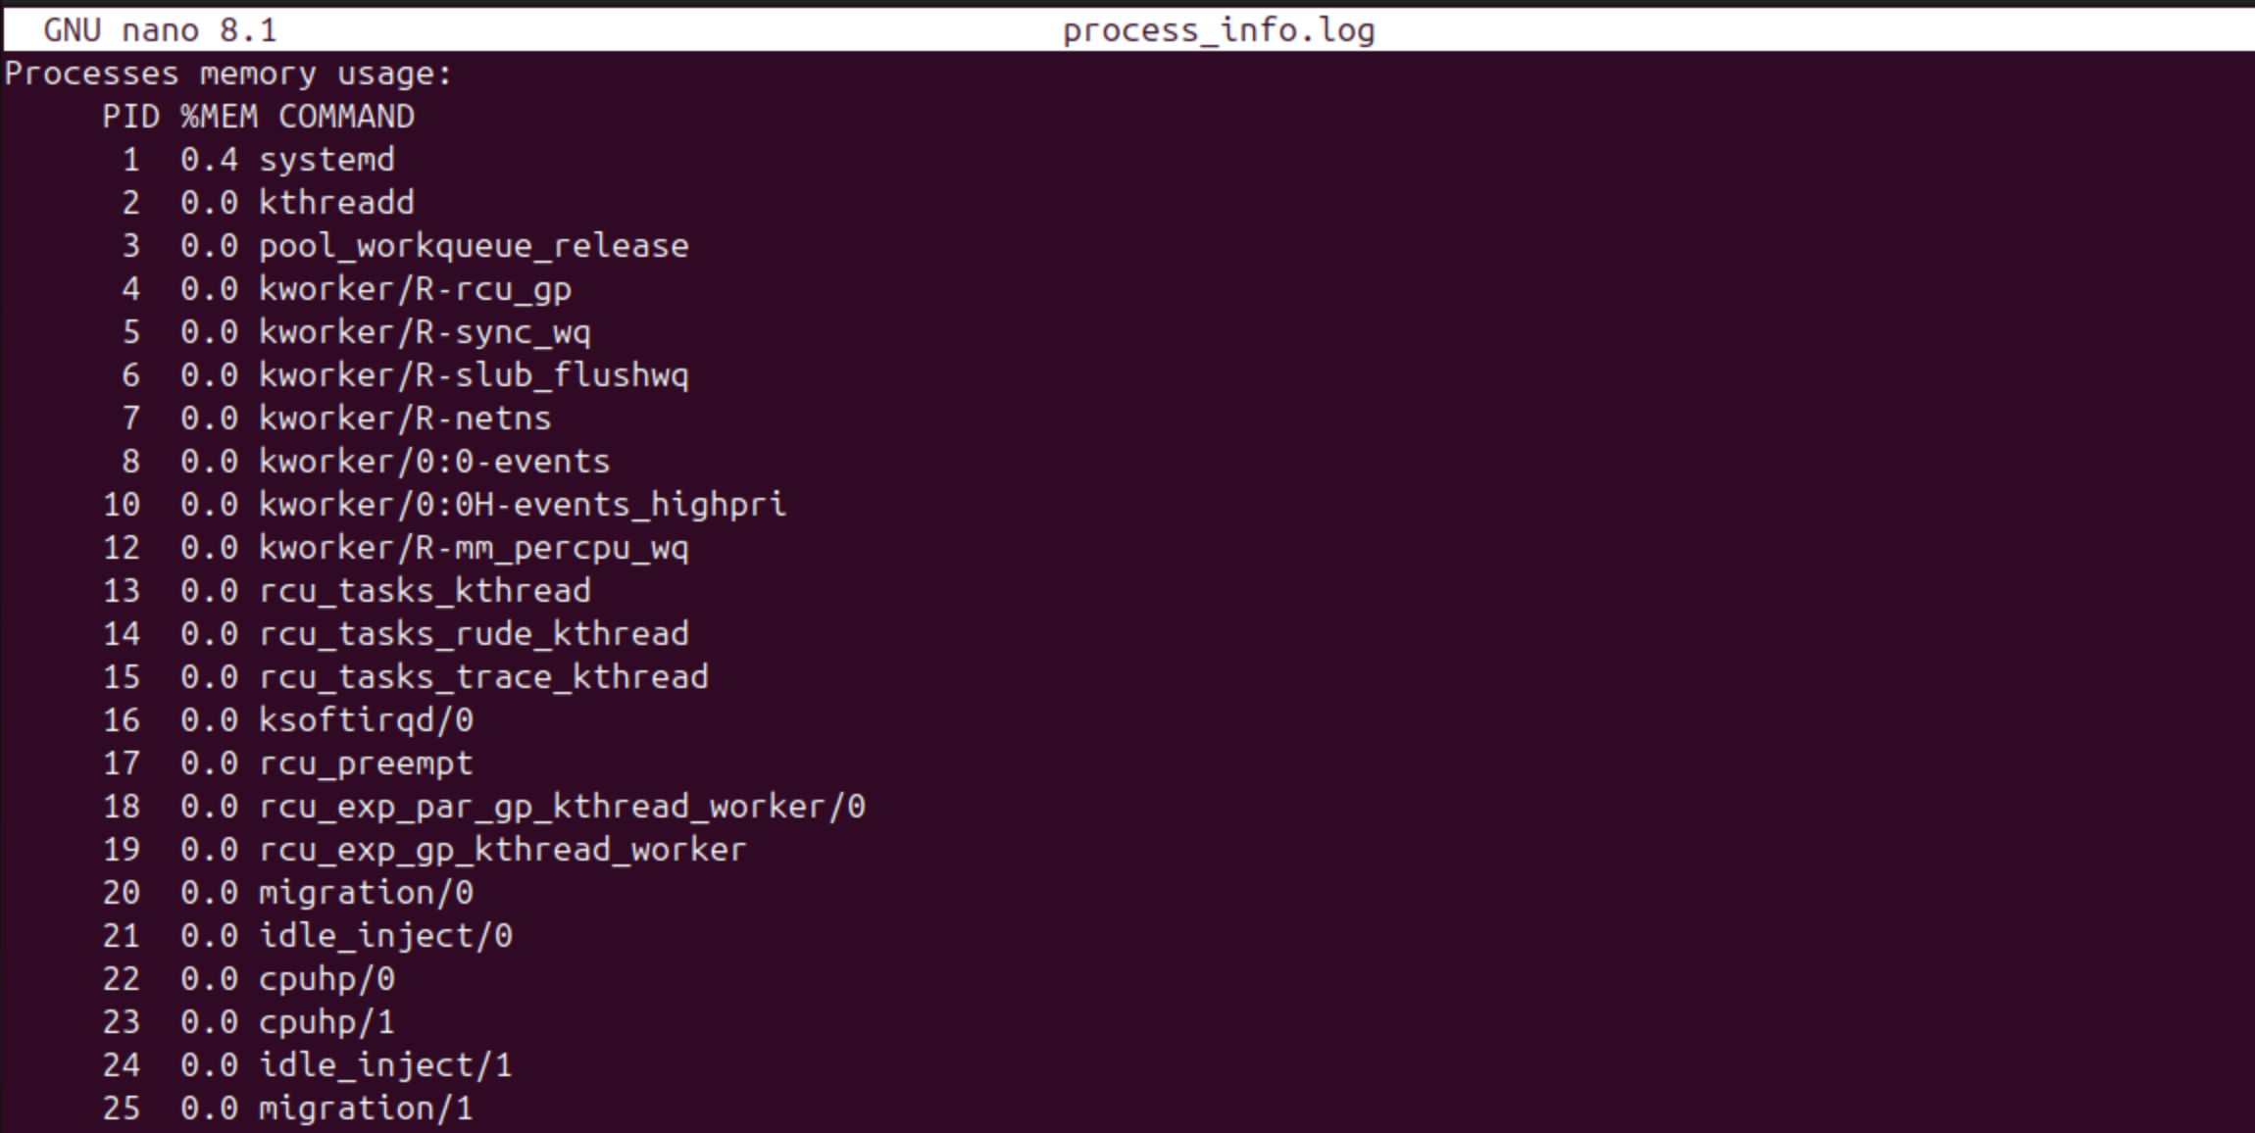… 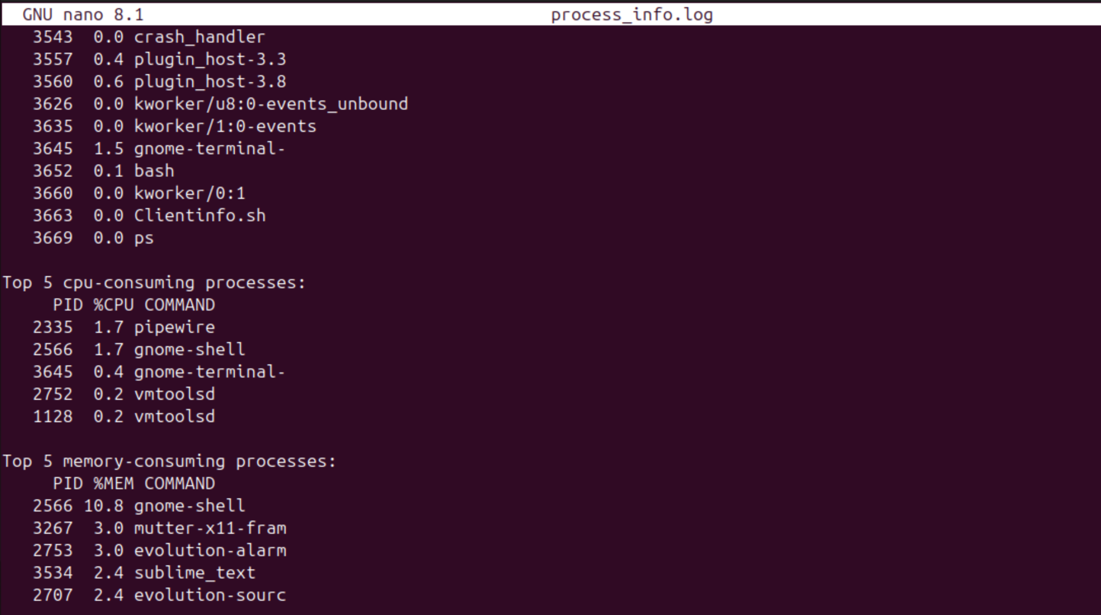

* ***Output sample of login.sh :***

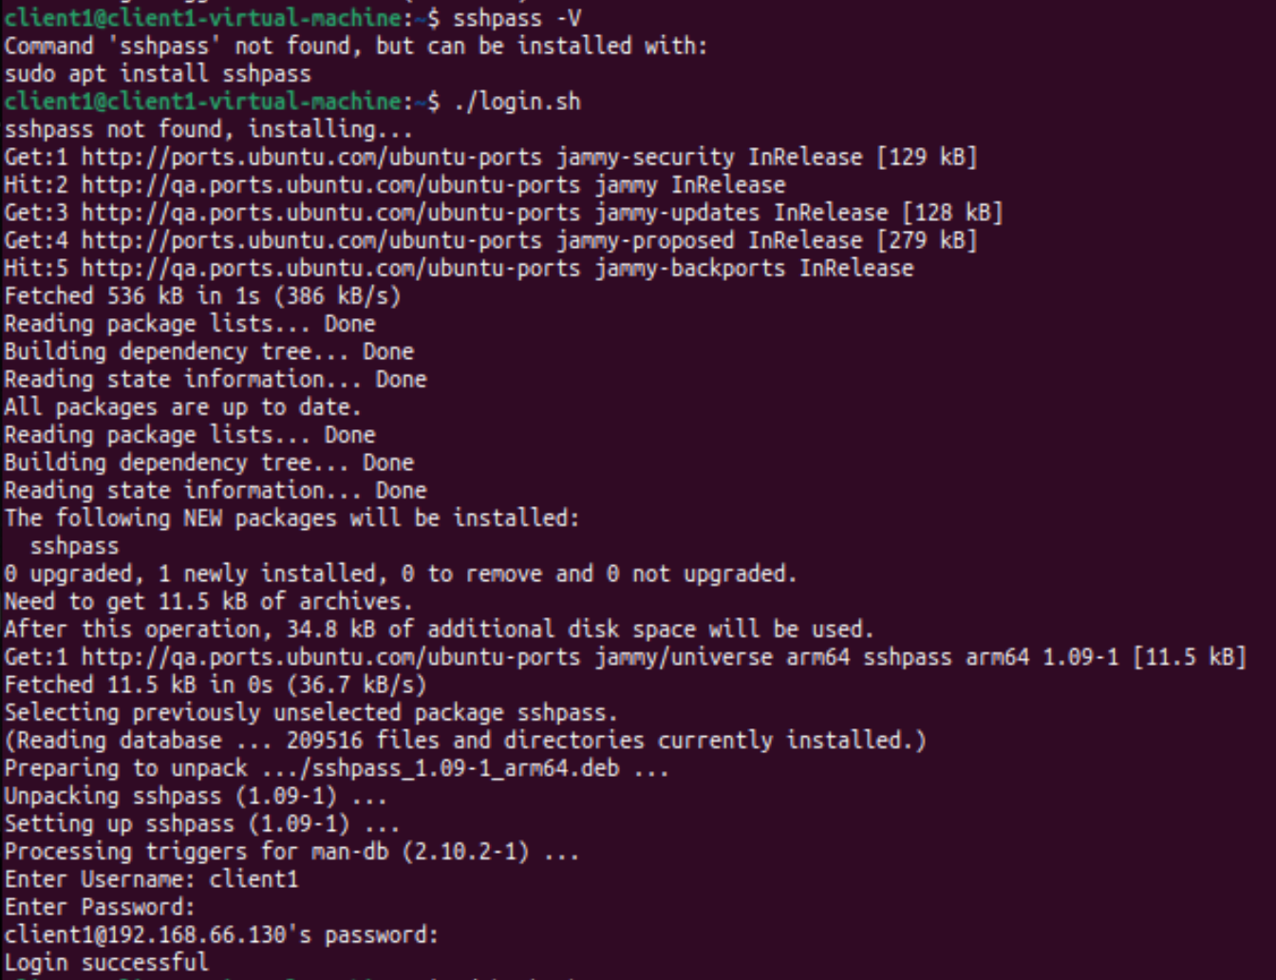

* ***Output samples of check.sh :***

